Microsoft SQL Server. Lab #1. Introduction to SQL. Distributions. Installing Microsoft SQL Server.
Target: teach how to correctly configure Microsoft SQL Server 2008 on both the server and client sides.
Theoretical material: Before performing the lab, it is recommended that you study Lecture 1, “Introduction to Database Theory,” which covers the basic concepts of databases, and Lecture 2, “Microsoft SQL Server 2008 Components,” which covers in detail all the main components of MS SQL Server 2008 that will be configured during this lab.
Reporting requirements: during the lab work, you will need to write a report. The information needed for the report will be indicated in the work by the words "Write down in the report...".

Task 1. Explore the SQL Server Configuration utility.
Instructions for implementation:
- On the server, run the SQL Server Configuration Manager utility and use it to determine the list of services running on the server. Record this list in a report.
- Note: Additional options for managing the operation of services are provided by the Windows XP Services administration utility, which is accessed via the Control Panel – Administrative Tools folder.
- On a server with installed MS SQL Server 2008, use the Services utility to determine the parameters for starting MS SQL Server services and record them in the report. (If you do not have access to the Services utility, then use SQL Server Configuration Manager).
- Determine which network libraries can be used to establish a connection to MS SQL Server (see Fig. 1.1). Which libraries are currently active? Record this information in the report.
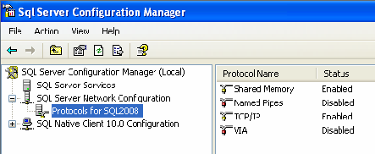
Fig. 1.1. Server-side protocols through which you can connect to it

- Using SQL Server Configuration Manager, determine which network libraries the client can use to connect to MS SQL Server (see Fig. 1.2). Write the list of libraries to the report.
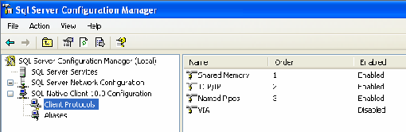
Fig. 1.2. Client-side protocols through which it can connect to the server

Task 2. Creating a server alias for client connections.
Before you start working with the server, you need to configure the connection parameters. To do this, in the SQL Server Configuration Manager utility, in the SQL Native Client Configuration – Client Protocols node, add the network library configuration, then specify the logical name of the server, select the required library from the list and define its parameters. For example, when interacting based on the TCP/IP stack, you need to specify the name of the network node on which MS SQL Server is installed and the TCP port number used for the connection (see Fig. 1.3).

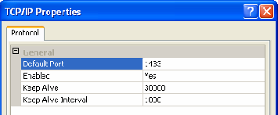
Fig. 1.3. TCP/IP protocol properties
Instructions for implementation:
- Determine and record in the report the network name of the computer on which MS SQL Server is installed.
- In the context menu (right mouse button) for the SQL Native Client Configuration – Aliases node, execute the New alias… command, set the Alias ​​Name to MyServ, select the TCP/IP protocol, and specify the previously defined name in the Server field.
- What port number should be specified when setting up this connection and why? Record in the report.

Task 3. Establish a connection to the SQL server.
Instructions for implementation:
- On the workstation – the client computer – start SQL Server Management Studio and select from the list the logical server name MyServ, defined in the previous task using the SQL Server Configuration Manager utility. If the required server is not in the list, you can select <Browse for more…> and find the required server in the list of servers to which a connection can be made.
- Connect to the MyServ server using MS SQL Server authentication: account "sa", no password.
- To write a new query, you need to execute the New Query command located on the SQL Server Management Studio toolbar. This will open a new tab that provides the following options:
  - a header that specifies the logical name of the server, the current database, and the name of the user who established the connection;
  - query area used to enter queries passed to MS SQL Server;
  - the results area, which displays the results of the query, and the display method is set by the Messages buttons (in the formtext) and Results (in the form of a table), respectively.
- Using the SELECT @@version command, determine and write to the report information about the version of MS SQL Server and operating system used (the query result should be displayed in text form) (Fig. 1.4).
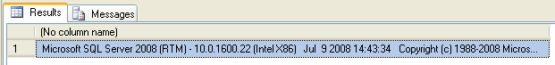
Fig. 1.4. Information about the MS SQL Server version
Note: To execute a query, you need to run the Query – Execute (F5) command, and to analyze the correctness of its syntax, you can use the Query – Parse (Ctrl+F5) command.
SQL Server Management Studio allows you to open multiple query windows and work with multiple databases simultaneously. Each window establishes its own connection to MS SQL Server based on different user accounts and their passwords. To create a new connection, use the File – New – Database Engine Query command.
The contents of the current connection request area can be saved to a file on an external drive using the File – Save command.
- Use the Object Explorer panel to determine the names of the supported databases and which server databases are system databases (to do this, expand the Databases node in the Object Explorer panel). Record this information in the report.

Task 4. Study the configuration parameters of MS SQL Server.
Configuration of the MSSQLServer service can be performed either by a special stored procedure executed in the SQL Server Management Studio utility, or graphically by means of the same utility. The choice of method does not matter, since the graphic method provides access to system data using the same stored procedure, only in a more visual form.
Instructions for implementation:
- To change the service settings using SQL Server Management Studio, select the desired server in Object Explorer and select Properties from the context menu. In the dialog box that appears, you can configure all the necessary settings.
- Display the list of MyServ server parameters (see Fig. 1.5).
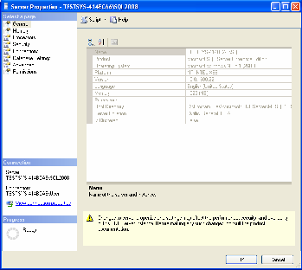
Fig. 1.5. MS SQL Server 2008 Properties
The General tab displays basic information about the system: operating system version, memory size, number of processors, etc., as well as server service startup parameters.
The Memory tab allows you to manage memory allocation for MS SQL Server actions: either dynamic memory management or set a fixed size.
The Security tab is used to define the user authentication type and also to define server access audit parameters. You can configure the server to use a specific account under which the MSSQLServer service will be launched.
The Connections tab allows you to configure client connections to the server. The maximum number of users that can simultaneously connect to the server. If zero is specified, their number is 32767.
The Advanced tab contains some general server settings. For example, you can define the default language for server messages or adjust year 2000 support, which determines how the last two digits of the year are interpreted.
The Database Settings tab is used to specify the settings for newly created databases: index parameters and parameters for working with backup devices, and the database recovery time.
- Determine and record in the report the server's root directory, the number of processors in the system, the user authentication type, and the maximum number of users supported by the server.
- Explore other MS SQL Server properties available in this dialog.

